

CSE541 Computer Vision

Weekly Report

Section-1

Group Name - Fantastic Four

Submitted to faculty: Prof. Mehul Raval

Date of Submission: 09 February 2022

Student Details

| Roll No. | Name of the Student | Name of the Program |
| --- | --- | --- |
| AU1940315 | Shubham Jain | BTech-CSE |
| AU1940169 | Gaurav Bajaj | BTech-CSE |
| AU1940215 | Raj Chauhan | BTech-CSE |
| AU1940118 | Raj Gariwala | BTech-CSE |

Tasks Performed in the week:

* In order to detect faces we first need to train a model with a good dataset. So to start with, the first step would be to make datasets of our images with a proper resolution, size, and dimension.
* So, this week we implemented a code, which will automatically start the connected webcam to the system and will take 10 pictures. These images will be cropped in such a way that only Faces would be recognized. We have implemented this program using the HaarCascade_FrontalFace program.

The outcome of the tasks performed:

* The program will take around 10 seconds to run and collect 10 images of users from the webcam. Hence, with this, we can produce a small dataset with proper quality to work with and later we can add more datasets having celebrities images.
* Now the next step would be to collect and gather more datasets and then to create and train the model to detect the faces in real-time with these datasets.
* Few Examples of HaarCascade program: -

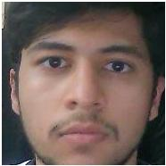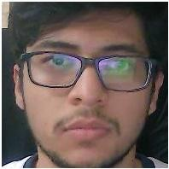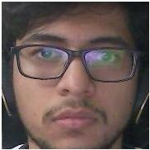

Tasks to be performed in the upcoming week:

* Learn more about Deep Learning, CNN, and specifically, Google’s Facenet.
* Select an appropriate dataset that aligns with the goal of the project.
* Develop a model using current datasets.